TC-CMS-012
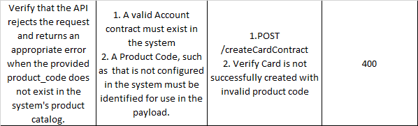
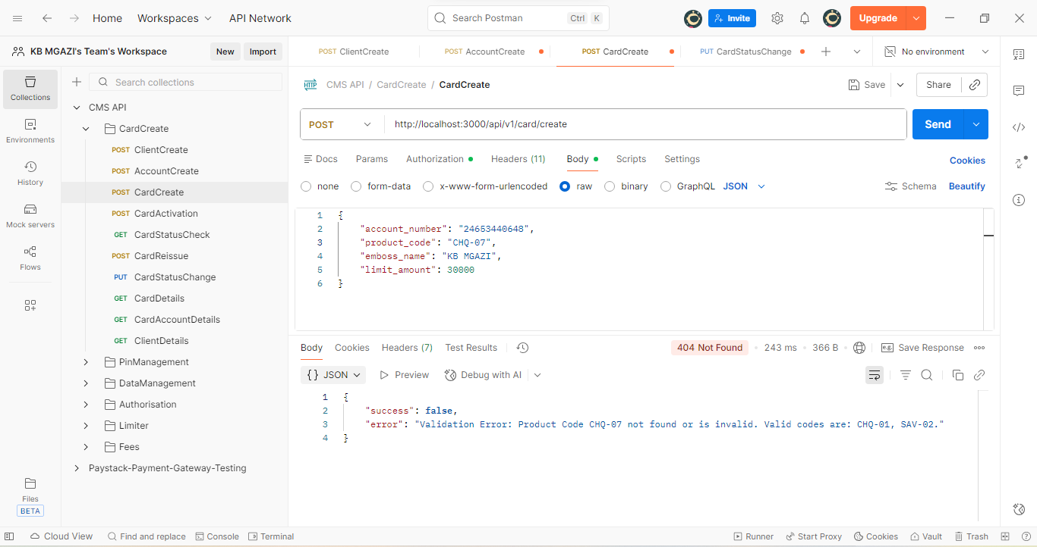
Request:
{
"account_number": "24653440648",
"product_code": "CHQ-07",
"emboss_name": "KB MGAZI",
"limit_amount": 30000
}

Response:
{
"success": false,
"error": "Validation Error: Product Code CHQ-07 not found or is invalid. Valid codes are: CHQ-01, SAV-02."
}

